***Introduction to Graphics and Mobile Gaming***

**Unity LAB 2**

**Chess Room Project**

**Issue 1.0**

Contents

1 Introduction 1

2 Create the new project 1

3 Navigating the scene view 1

4 Basic tools 2

5 Creating the scene 2

5.1 Creating a plane 2

5.2 Creating the skybox 3

5.3 The room 4

5.3.1 Imports 4

5.3.2 Building the room 6

6 Installing on device 8

7 Appendix 8

# Introduction

In this lab, we will begin working on our Chess environment, with a view to setting our scene for us to start creating our play area. This is the plan we will follow for the coming labs:

* Gaming – Lab 2: The creation of the basic environment where we will be working, by creating a plane in the foreground and a skybox in the background. We will then create the chess room where the gameplay will take place.
* **Gaming – Lab 3**: We will look at the use of custom shaders in C#. We will learn how to place lights and create shadows, as well as how to add dynamic elements to the shadows so the user can change them during gameplay. We will also create a GUI that will allow you to interface with the environment and the camera.
* **Gaming – Lab 4**: We will look at cameras, and specifically how to setup a movable first person camera. We will enable the user to move the chess pieces placed around the room. Then, we will add a points counter, a target, and a timer in order to add a win/loss condition. We will also finish off our scene by creating menu features, particle effects, and other visual flare.

# Create the new project

Open Unity, then in the first window that displays, click ***New***. Ensure you name the lab something recognizable, such as “Lab2” and then choose where you want to save this project. Select the 3D option and then click **Create.**

We are greeted by the main Unity Editor. Let’s go through a few of the components we can see. At the center of the screen is the **scene** where you will place and be able to view all of the needed assets. On the left-side, you will see the **Hierarchy panel**; here, you will find a list of all assets present in the scene and their relative hierarchy to each other’s. At the bottom are the **Console** and **Project** panels, the project panel allows you to navigate through your folders and access assets. Finally, on the right, you can find the **Inspector** panel; every time something is selected, the inspector will give you information on the object as well as its properties.

# Navigating the scene view

There are a few basic commands to maneuver around the scene view.

* To move the view up and down: **Ctrl + alt + left click** or click the scroll wheel and then move your mouse.
* To zoom in and out: **Ctrl + alt + right click** and move the mouse; or use the scroll wheel or use the up and down keys. To move the view around a fixed point: right-click and move the mouse left, right, up, or down.

# Basic tools

When working in Unity, you will have to move, scale, and rotate assets often. In the top left-hand corner, there are a few buttons to select what actions you can carry out when moving the mouse.

The first option allows you to grab the view and move it by left-clicking. **Main tools**

The second option is the standard mode, which allows you to move with the commands we looked at earlier. If you select and object when using this mode, you will be able to move the object on the x, y, z axis by clicking and dragging the corresponding arrows.

The third and fourth options allow you to rotate and scale objects when they are selected, respectively.

# Creating the scene

## Creating a plane

Our first task is to create a plane. This is where we will later place all of our assets to build our Chess Room. To do this, click on the **GameObject** option at the top of the screen and then select **3D object** and then **Plane**. Select the plane and make sure its position is 0, 0, 0 in the Inspector window.

This should by default show up as a white plane. To change its colour, click on **Assets** in the Project tab and then right-click on create->folder, name the new folder “materials”, open the folder, and using the same instructions, create a new material and name it “plane colour”.

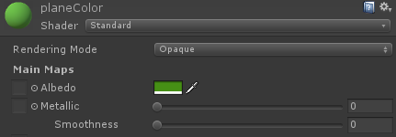With the new material selected, we can now access all of its settings from the inspector panel. Since we only need a new colour, select the colour you prefer from the **Albedo** option and set Metallic and Smoothness to zero.  
Then, drag the new material from the Project panel to the plane in the scene window to apply it.

Alternatively, from inside of the materials folder, **right-click->Import new asset**, and look for the ‘Assets’ folder. Navigate to **assets->materials** and select ***“grass.tga”***, and then drag the new texture onto the plane. This will automatically create a new folder with the grass material inside.

Select your plane and then scale it on X and Y axes to make it large enough to host the room you will create (scale it up 20 times its original size, using the scale in the inspector panel, if you want a reference to see how big the plane is, add a cube from GameObject->3D Object->Cube)

## Creating the skybox

Next, we should look at how to create and implement our own custom Skybox into Unity; this will allow us to tailor the background of a scene to suit the environment we are trying to create.

* First, create a new folder in the assets folder called *“skyBox”*
* Right-click on a blank space in our new folder and create a new material called *“MT_skyBox”*.
* From the inspector tab, change *“Shader”* from **standard** to **6 sided**. Unity now asks us to provide 6 textures for the skybox.
* To add the six textures, open the ‘Assets’ folder provided, open the skybox folder, and then select and copy all of the six images.
* In Unity, from the project tab, navigate to the **skybox folder** and create a new folder called *“skyImages”*
* Right-click on the new folder, select show in explorer, and then open the folder and paste the six images, Unity will automatically import them for you.
* Now, select MT_skyBox again, go to the inspector tab, add the textures by clicking on **Select** next to ”Front [+Z]” and then select *“sunny1_front”*.
* Do the same for all of the other sides of the skybox, making sure to match the side with the right texture.
* To apply the new skybox to your scene, drag it on the screen (though not on the plane).

You should now have a visible skybox in your scene!

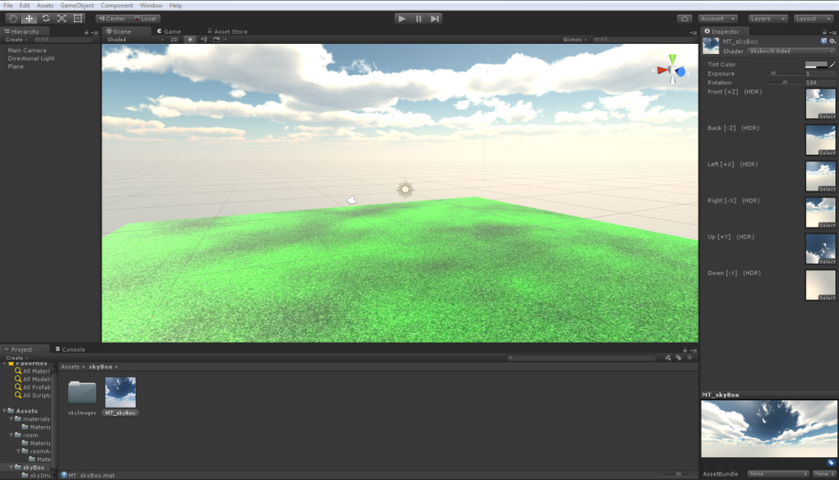

## The room

### Imports

Now that we have created the basic environment, let’s start creating the room. When creating a new in-game object in Unity, you will generally use an asset or a series of assets to do so. These will be 2D or 3D meshes, with textures or materials applied to them. In this part of the lab, we will look at how to set up our own meshes and materials and then import them to start building the room.

The first thing we do is create a new folder in the assets folder and name it *“room”.* Create a subfolder and name it *“roomAssets”*.

* Right-click on the folder and click on **Show in explorer** and open the folder.
* Copy all of the assets from the assets folder from the lab material and paste them here (do **not** copy the **Materials** folder or the Materials.meta file inside the roomAssets, Unity will create the materials file by itself).
* Close the folder, Unity should now have imported all of the new assets.

Now, try to place a door on your scene. It will be extremely small; let’s scale it up by 100.

As you can see, the door is white; this is because we still need to apply a texture to it.

To fix this, we need to import the required textures, following the same process we have used to import the room assets. Add another folder to the *“room”* folder and name it *“roomTextures”* and then import the textures (do **not** copy the **skybox textures**; we’ve already covered that); you can find them inside the ***Assets->room>textures folder***.

* Double-click on the door in the scene window or open the hierarchy of the new object and click on detail_01.004

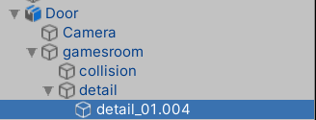

* + In the Inspector tab, next to “a1_door01”, click on *“Standard”* and change the shader to *“Bumped Diffuse(Mobile/Bumped Diffuse)”*
  + Click on the small arrow and expand the “a1_door01” section, you will see Unity asks you to select two textures for “Base (RGB)” and “Normalmap”.
* Click on select for the texture related to *“Base (RGB)”* and select the “a1_door01” texture
* Repeat the same for “a1_atlas_01” using the texture named: “a1_atlas_01”

If you delete the door and place it again, the texture will be updated correctly.

**If you encounter any problem trying to change the shader from a1_door01 from Standard to Bumped Diffused:**

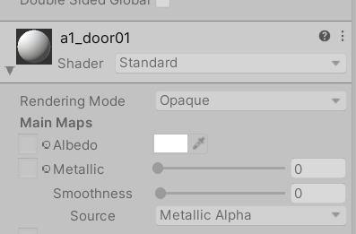

Click on the asset that you want to use and go to inspector > Materials > Extract Materials > choose the same folder, and now you should be able to modify the shader

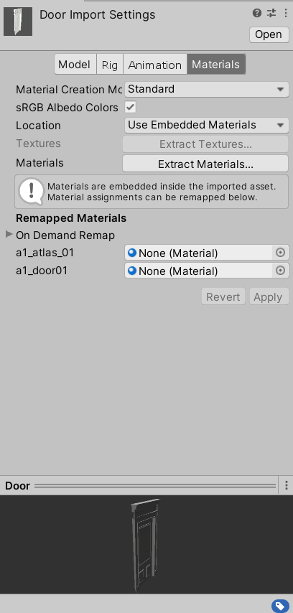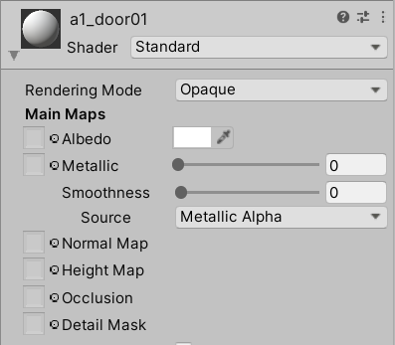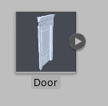

### Building the room

Now that we’ve looked at how to apply textures to the meshes needed to create the room, we can start creating it. If you have any problems, please refer to the appendix at the end of this lab.

Our first step is to put the skeleton for the room.

* Drag the *“roomSkeleton”* in the scene.
* Re-scale it from the Inspector window to scale x=100, y=100, z=100; this will allow us to have a wide view of the room when the player steps inside, and smoother movement.
* Once the skeleton has been placed, the room should look pretty big from the player’s perspective.

You may have already noticed when setting up the door that one side of the asset can either be partially or completely invisible, this is due to culling some of the vertices that will not be visible when the game is playing. Rotate the door until only the visible part is inside of the room.

Currently, our room is pretty empty. We should populate it with our 3D assets and textures. Select the “window” mesh and place it in the scene, scale it to the same scale of the room (~100x in all coordinates, adjust where needed)

* Double-click on the new window mesh and, as we did for the door, add the texture “a1_atlas_01”. Then, place correctly inside the wall.

Continue to place all of the needed elements for the room; the process to apply the correct textures and move meshes is always the same. Though be sure to consult the appendix for details on positioning and other parameters.

If you need to import any new or custom meshes or textures, just right-click in the console panel and select “Import new Asset”

Here is how the room should look when completed:

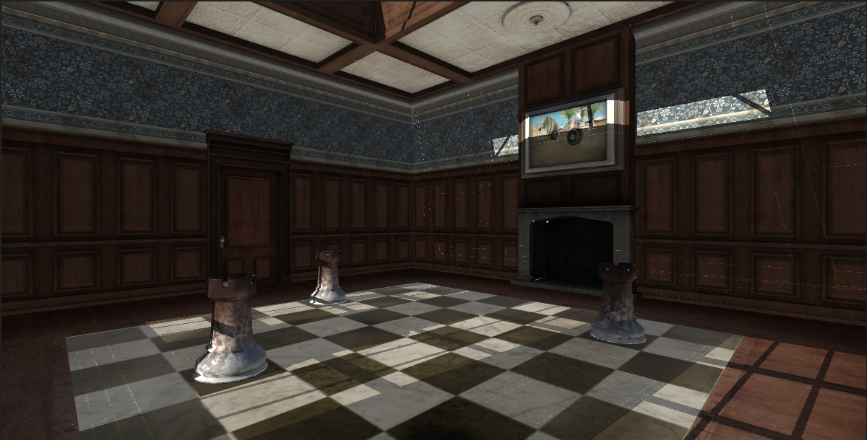

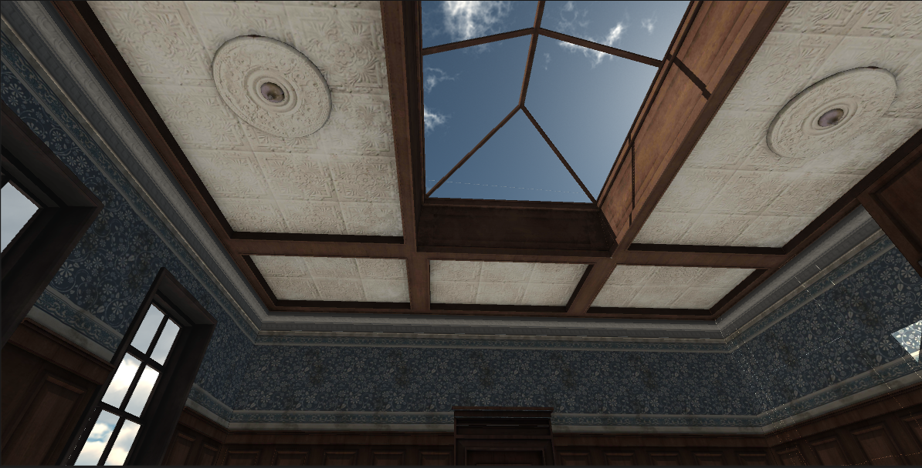

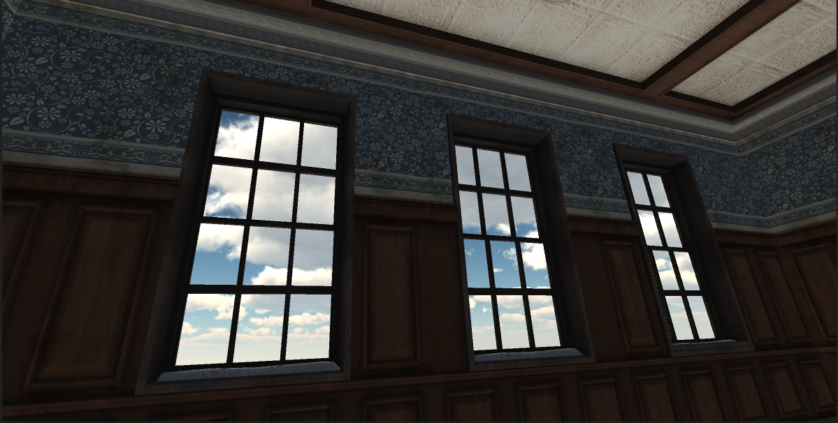

# Installing on device

* Let’s now install the chess room on your android device; firstly, let’s place the camera in a good spot for the user to view the scene from. Bear in mind, we are not yet able to move around the room during gameplay.
* From the Hierarchy panel, select the camera and place it in a suitable position.
* Make sure you connect your device to your PC.
* Navigate to File and then Build Settings. Please select the Android under Platforms. You will notice that the Build and Run button is gray and cannot be clicked. That is because we need to re-build the project for Android devices. Please Select ‘Switch Platform’ and wait for the magic to happen.
* Now click Build and Run, and if everything goes smoothly, the app should pop up on your device.

Open the application on your device and see how the room looks, you should not be able to see any noticeable gaps or spaces in the environment. If you do be sure to move the assets around the room to enable a seamless view.

# Appendix

When placing the doors, you will be able to see empty spaces around the door frame; this is because you will need to place the 2 sidewalls named “wallShortSide” behind each door.

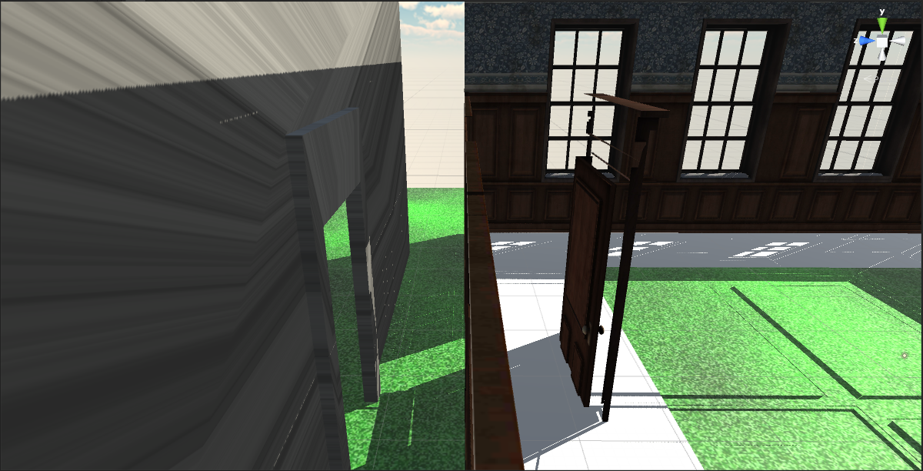

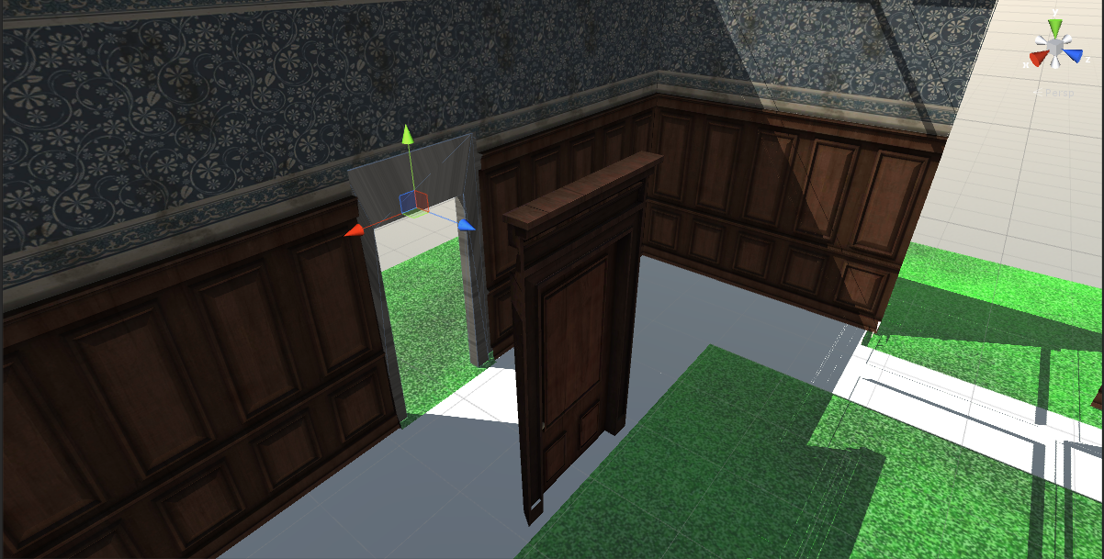

You may have already noticed that when we placed the skeleton for the room, the ceiling and the floor are both white/gray. To apply the correct texture, do as previously done for the door and select “a1_atlas_03” texture.

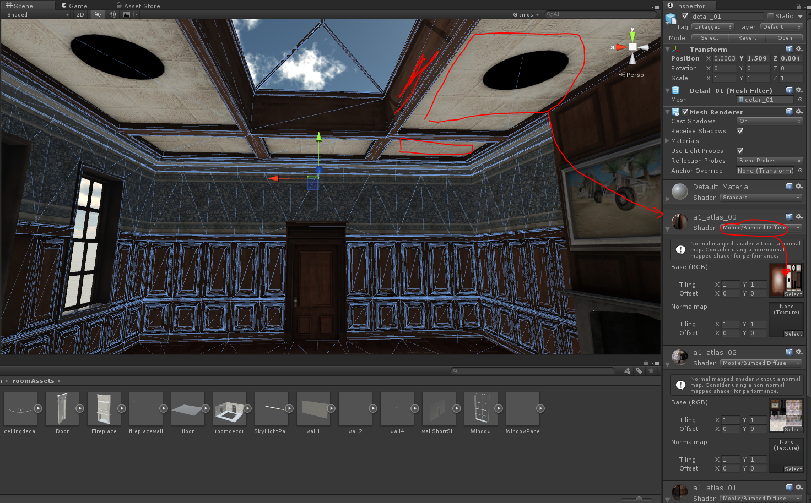

When creating the chess board, the texture used is within the textures folder for the room. The best way to do this is to create another plane as done for the grass one and apply the chessboard texture to it.

The correct texture to apply to the “tower” mesh is the “*a1_chessPiece”*.

As we did for the chessboard, add the provided mesh, scale it properly, and then drag and drop the marble texture on the mesh

